**ASSIGNMENT 7**

**1.Using Insert Function, give examples of any function available in the**

**different dropdowns present in the function library. For example**

**AutoSum, Recently Used, Text, Date & Time, etc.**

**Ans.** Use the**Insert Function** dialog box to help you insert the correct formula and arguments for your needs. (To view the **Insert Function** dialog box, click **(fx)**

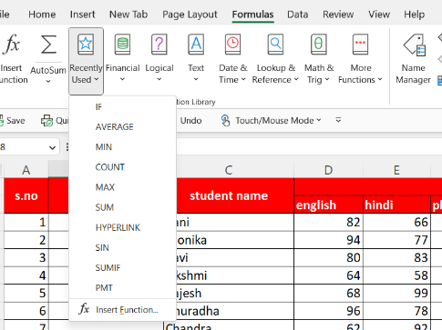 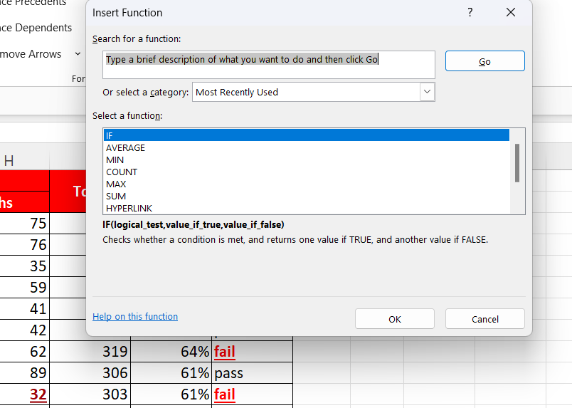

**Search for a function**

Type a brief description of what you want a function to do, and then choose **Go**. A list of functions likely to fit your needs and based on your description will display in the Select a function box.

**Or select a category**

From the drop-down list, do one of the following:

* Select **Most Recently Used**. Functions you have inserted in the recent past will display in alphabetical order in the **Select a function** box.
* Select a function category. Functions in that category will display in alphabetical order in the **Select a function** box.
* Select **All**. Every function will display in alphabetical order in the **Select a function** box.

**Select a function**

Do one of the following:

* Click a function name to see the function syntax and a brief description immediately below the **Select a function** box.
* Double-click a function name to display the function and its arguments in the **Function Arguments** wizard, which helps you add correct arguments.

**Help on this function**

Displays the reference help topic in the Help window for the currently selected function in the **Select a function** box.

For an overview of creating formulas, see [Overview of formulas in Excel](https://support.microsoft.com/en-us/office/overview-of-formulas-in-excel-ecfdc708-9162-49e8-b993-c311f47ca173).

**2. What are the different ways you can select columns and rows?**

**Ans.** Select the letter at the top to select the entire column. Or click on any cell in the column and then press Ctrl + Space.

1. Select the row number to select the entire row. Or click on any cell in the row and then press Shift + Space.
2. To select non-adjacent rows or columns, hold Ctrl and select the row or column numbers.
3. Or to select any particular area select normally With the help of mouse and by clicking (shift + arrow keys).

**3. What is AutoFit and why do we use it?**

**Ans.** Excel's AutoFit feature is designed to automatically resize cells in a worksheet to accommodate different sized data without having to manually change the column width and row height.

**AutoFit Column Width**- changes the column width to hold the largest value in the column.

**AutoFit Row Height** - adjusts the column width to match the largest value in the row. This option expands the row vertically to hold multi-line or extra-tall text.

AutoFit columns and rows with a double-click

The easiest way to auto fit in Excel is by double-clicking the column or row border:

* To autofit **one** **column**, position the mouse pointer over the right border of the column heading until the double-headed arrow appears, and then double click the border.
* To autofit **one row**, hover the mouse pointer over the lower boundary of the row heading, and double click the border. AutoFit columns and rows by using the ribbon

Another way to make Excel cells expand to fit text automatically is by using the following options on the ribbon:

To **AutoFit column width**, select one, several or all columns on the sheet, go to the Home tab > Cells group, and click Format > AutoFit Column Width.

To **AutoFit row height**, select the row(s) of interest, go to the Home tab > Cells group, and click Format > AutoFit Row Height.

AutoFit column width and row height using a keyboard shortcut. Those of you who prefer working with the keyboard most of the time, may like the following way to auto fit in Excel:

1. Select any cell in the column/row you want to autofit:
   * To autofit **multiple non-adjacent columns/rows**, select one column or row and hold down the Ctrl key while selecting the other columns or rows.
   * To autofit the **entire sheet**, press Ctrl + A or click the *Select All* button.
2. Press one of the following keyboard shortcuts:
   * To **AutoFit column width**: Alt + H, then O, and then I
   * To **AutoFit row height**: Alt + H, then O, and then A

**4. How can you insert new rows and columns into the existing table?**

**Ans.** we can insert new rows and columns into the existing data by following these steps:-

1. **To Insert COLUMN:-**

* click on the column names place the cursor on the column before which you want to add new column.

Right click and a dialogue box will open , select insert and a new column will be inserted on the left side of selected column name.

* Also, in the **ribbon > home > cells > insert > insert sheet columns**.

By using **keyboard shortcut:-**

* Click on the *letter button* of the column immediately to the right of where you want to insert the new column.

**Tip.** You can also pick the entire column by selecting any cekk and pressing the ctrl + space shortcut.

* Now just press ctrl+ shift+(+, on the main keyboard).

1. **To Insert Row:-**

* click on the row numbers place the cursor on the row number before which you want to add new row.

Right click and a dialogue box will open , select insert and a new row will be inserted above the selected row number.

* Also, in the **ribbon > home > cells > insert > insert sheet rows.**

By using **keyboard shortcut:-**

* Select the row number above which ypu want tp add new row.
* Now just press ctrl+ shift+(+, on the main keyboard).

**5.How do you hide and unhide columns in excel?**

Ans. Hide columns

1. Select one or more columns, and then press Ctrl to select additional columns that aren't adjacent.
2. Right-click the selected columns, and then select **Hide**.

**Note:**The double line between two columns is an indicator that you've hidden a column.

Unhide columns

1. Select the adjacent columns for the hidden columns.
2. Right-click the selected columns, and then select **Unhide**.

    Or double-click the double line between the two columns where hidden columns exist.

6. Create an appropriate table within the worksheet and use different

functions available in the AutoSum command.

Ans. 